SOLUTIONS

- C. Starting with 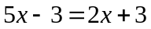, subtract 2x from both sides, then add 3 to both sides, resulting in the equation 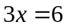. Divide both sides by 3, resulting in the answer .

- C. Arrange the given values in order from least to greatest: 1, 2, 2, 3, 3, 4, 5. The median is the middle number; in this case, 3.

- D. Using order of operations, 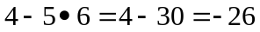. The absolute value of -26 is 26.

- B. The numerator can be factored into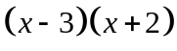. The denominator can be factored into 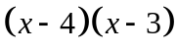. As both the numerator and the denominator include an 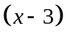, you can cross both of those out, resulting in the expression 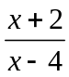.
- B. Use distance formula:.
- A. By definition, the slope of a line equals 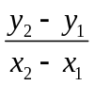. Plugging in (7 , 4) and (-11 , 21) into the formula, we get a result of: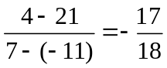.

- C. By order of operations, we must address the 4☺2 first. Plugging in 4 and 2 for a and b respectively, we get a result of 6. Now we need to find 6☺3. Plugging in 6 and 3 for a and b respectively, we get a result of 15.

- C. Let the two numbers be x and y. So, 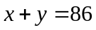and 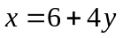, as given in the problem. Substitute x in the first equation with 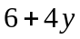, resulting in the equation 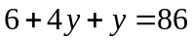. This simplifies to 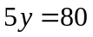. Divide both sides by 5, getting that 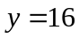. It is now clear that 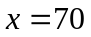. Multiply 16 and 70 to get the answer: 1120.

- D. 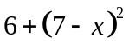.

- B. Using order of operations: .

- B. Substitute x with 16 in the given function: .
- C. Simplify the denominator of the overall fraction first: 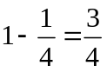. Now, evaluate 6 divided by , which is really 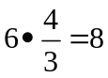.

- C. George’s father starts at point (1, 2), and ends at point (-3, -6). Using midpoint formula, we find the midpoint to be (-1, -2).

- C. The square root of 361 is 19. By definition, when you square root an exponent, you divide said exponent by 2. Therefore, the square root of 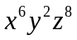is 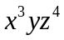. So, the answer is: 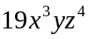.

- A. The GCF of 12 and 8 is 4. The GCF of 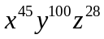and 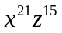is. So, the answer is: 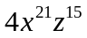.

- B. By definition, as the line George’s mom is driving on is perpendicular to the line that George’s dad is driving on, the slope of the line that Mom’s driving on is 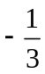. As the question also gives us a point on said line, we can use point-slope form, resulting in the equation: 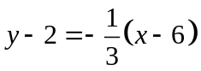. This simplifies to: 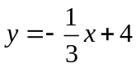.

- D. Let c be the number of chickens they own, and p be the number of pigs they own. We are given that 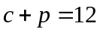, and that 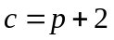. Substitute the c in the first equation with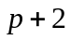, obtaining the equation 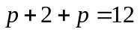. After some simplifying we find that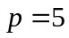. So, 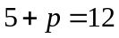, and 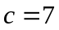.

- B. We are given that 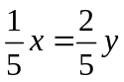. Multiply both sides by 5, then divide both sides by y, resulting in the equation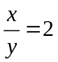.
- A. George now has 34 cups of medicine left. 34 is 34% of 100.

- C. The square of 4 is 16. By definition, when you square an exponent, you multiply said exponent by 2. Therefore, after squaring the given expression, you obtain the expression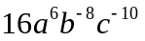. As the questions calls for only positive exponents, the b and c variables are moved down to the denominator, obtaining the final answer of 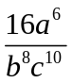.

- A. Since he already has 10 dollars on him right now, he only needs to pay 70 more dollars. Divide 70 by 5 to get the answer: 14 hours.

- E. First, add bx to both sides, resulting in the equation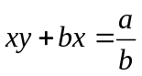. You can take out a x on the left side of the equation, resulting in the equation 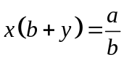. Divide both sides by 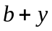 and simplify, resulting in a final answer of 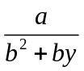.
- B. Let x be the amount of money Dad had in his wallet before he started buying things. Since he spends of his money on flea powder, he now has 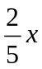left. He then spends of his remaining money, or 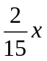, on shoe polish, leaving him with 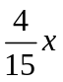left. So, = 4. x must equal 15.

- D. By definition,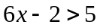 OR 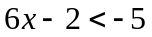. Solving both equations, we get that 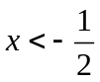 OR 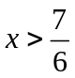.

- D. Since George’s dad has a 3 hour head start, he has already traveled 60 miles by the time George realizes he also used antifreeze, and it is now 10:00 A.M. As Dad travels at 20 mph, and George at 40 mph, we can set up the following equation: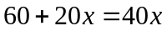, with x being the number of hours that have passed since George started chasing after his dad. Subtract 20x from both sides of the equation, then divide both sides by 20, resulting in x being 3 hours. So, George will catch up to his dad at 1:00 P.M.

- C. Subtract 4 from both sides of the equation, resulting in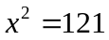. Taking the square root of both sides, we get that 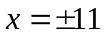.

- B. By definition, parallel lines have equal slope. So, the answer is .

- A. 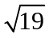 is approximately 4.359. So, for 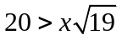, x must be smaller than 4.359. The only answer choice that fits this condition is A.

- B. Set up three equations: 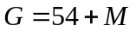;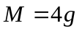; and 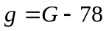, with G being Grandma’s age, M being Mom’s age, and g being George’s age. Substitute M with 4g in the first equation, resulting in the equation 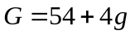. Substitute g with 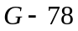 in the same equation, resulting in the equation 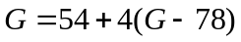. Distribute the 4 and simplify, resulting in the equation 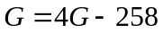. Subtract 4G from both sides, getting 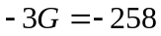. Divide both sides by -3, resulting in the answer 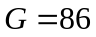.

- E. With the given information, you can set up the equation 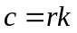, with c being the number of cats at any given time and r being the number of rats at any given time (and k being the constant, as usual). Plugging in 60 for c and 20 for r, we find k to equal 3. Now plugging in 30 for r, we get the equation 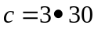. After simplifying this, we obtain the final answer of 90.

